Low Level Design (add product module)

Project Code | Team 5
Project Name | Asset Management System

Prepared/Modified by | Role | Date of Preparation
Team 5 | Software Engineer | 01/11/2017
Reviewed by | Role | Date of Review
Prabhjot Singh,Rahul Yadav | Software Engineer | 01/11/2017
Approved by | Role | Date of Approval
Zainab F Kulkarni | Training Manager
Circulation List | shweta.a.tripathi@capgemini.com,  vinayak.kedia@capgemini.com,  sayantani.banerjee@capgemini.com,  snehal.bagade@capgemini.com,  rohit.khandagale@capgemini.com,  pranjali.gupta@capgemini.com,  rahul.mukherjee@capgemini.com. | Version Number of the template:1.0
Version Number | 1.0

Table of Contents

1. Description Of The Unit 3
2. References 4
3. Dependencies / Assumptions 5
4. Class Diagrams 6
5. Sequence Diagrams 7
6. Design Components 8
6.1 List Of UI Components 8
6.2 List Of Design Classes 8
7. Re-Usable Routines/Components 9
8. Messages 10
9. Configuration Files 11
10. Crud Matrix Table 12
11. Data Mapping Matrix 13
12. Action Flow Matrix 14
13. Stored Procedures 15
14. Program Specification / Pseudo Code 16
REVISION HISTORY OF THE WORK PRODUCT 17

Description Of The Unit

The Raise Request module allows the Manager of the application to raise a request for assets on behalf of his/her employees into the database. This module can be used by the manager of the application.

On clicking on the Raise Request button in the “ ” page, the manager is redirected to the Asset Request form page. The manager enters all the details of the asset like asset ID, allocation ID and asset quantity and insert request to the application. If the entered asset details are invalid, appropriate error messages are displayed.

After entering all the asset details, the details are inserted into the database on clicking the Raise Request button.

After raising the request, Manager can view status of the requests raised by him by clicking on the View Status button on the basis of Allocation ID.

References

Reference | Description
Repository reference | https://IGTEBLRSVNTNG.igatecorp.com/svn/B230Jul15PLPTeam5_JEE
Class Diagram | /Project Documents/Design Documents/HLD/Class Diagrams/ Class Diagrams
URS | /Project Documents/Requirements/Case Study/ Asset Management System .doc
UTP | /Project Documents/Test Plan/UTP/Test Case/ Test_Asset_Management_Module.xls
DB Design | /Project Documents/Design Documents/HLD/DB Design/ Asset Management System_Team5_DBDESIGN.xls

Dependencies / Assumptions
Dependencies:
The manager or admin should be logged in.

Assumptions:
The asset details are stored in the database.

Class Diagrams

Class Diagram

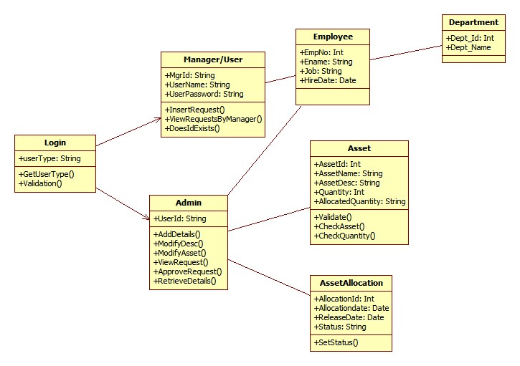

Sequence Diagrams
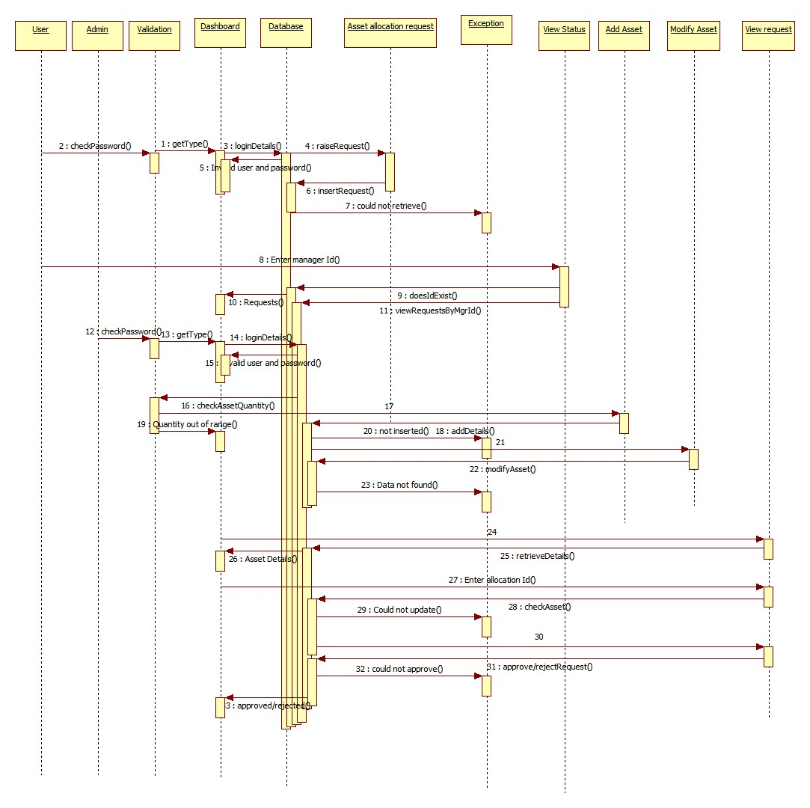

Design Components

List Of UI Components
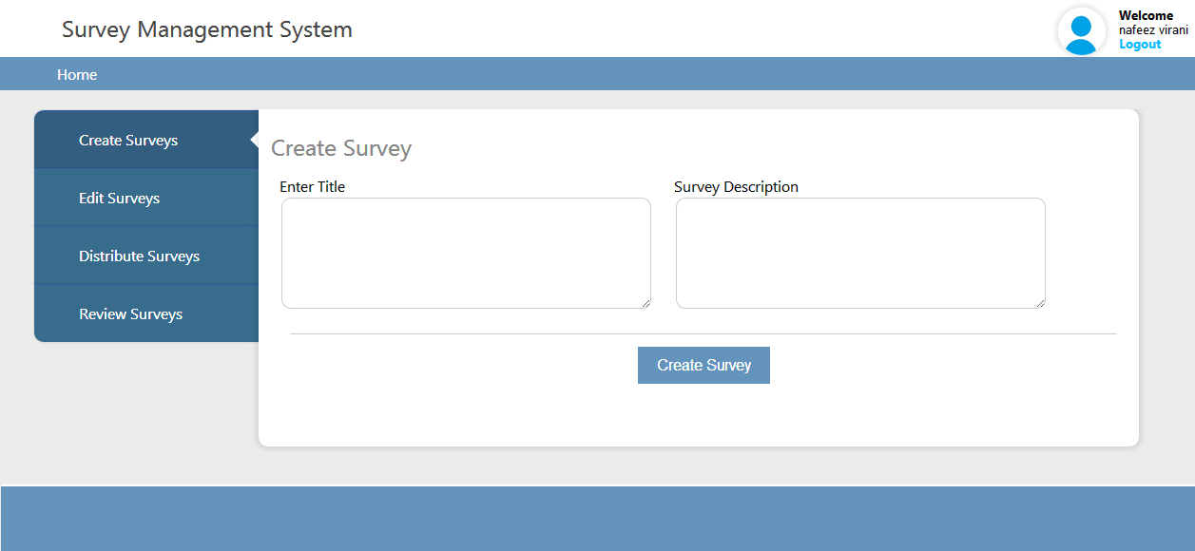
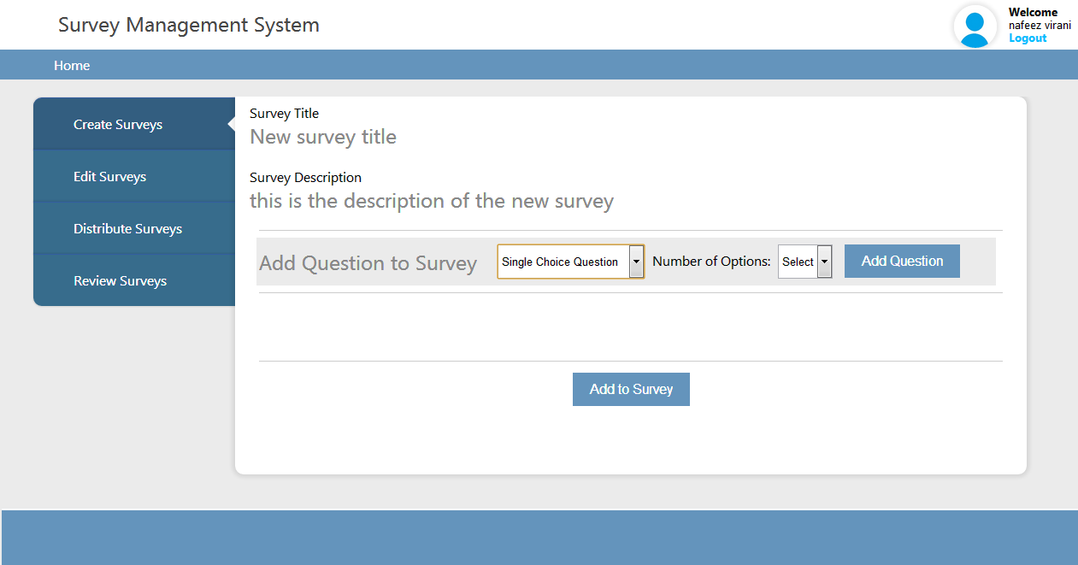

List Of Design Classes
Sr. No. | LLD Name | Class Name | Method Name | Method Description
1 | Create Survey Module | Asset,  AssetAllocation,  Employee,  Login | Appropriate Getters and Setters methods, | Getters and Setters are used to retrieve and set the property values respectively.
2.1 | Asset Module | AssetController, | Home(HttpServletRequest request,Model model): String  ModelAndView RaiseRequest(HttpServletRequest request,Model model)  InsertRequest(@ModelAttribute("allocation") @Valid AssetAllocation assetRequest ,BindingResult result,Model model,HttpServletRequest request): String  ModelAndView ViewStatus(@RequestParam("allocationId") int allocationId, HttpServletRequest request)  logoutAction(HttpServletRequest req,Model m): String | After successful login, it goes to the HomePage where we will get the two options  1. Raise Request 2.View Status  1. Raise Request  It sends allocationId and empId to the jsp page.  We will enter the quantity and based on that, data will be inserted into the table.  2. View Status  We will fetch the allocationId from the table and based on that the Asset Allocation Details will be displayed.  LogOut will go back to the Login page and the session will get expired
2.2 | Asset Module | LoginController | goToIndex(Model model): String  check(@RequestParam("userName") String username, @RequestParam("userPassword") String password,Model model,HttpServletRequest request): String  againToIndex(Model model): String | It will go to login details page which will ask for the login details  After inserting the login details if it is not valid it will redirect to the same login page, otherwise it will go to the HomePage.  After session expires it will ask again for the login details.
3 | Asset Module | AssetAllocationService | AssetAllocation addAssetRequest(AssetAllocation assetRequest,String mgrId)  List<String> getAssetIds()  createSurvey(survey: SurveyBean, quesList: List<QuestionBean>):Boolean. | Calls createSurvey() of SurveyorDAOImpl class and returns the result to SurveyController.
4 | Asset Module | AssetDao | createSurvey(survey: SurveyBean, quesList: List<QuestionBean>):Boolean. | Creates a survey by inserting the survey details into the database and returns the result to SurveyServiceImpl.

Re-Usable Routines/Components

Re-Usable Routines/Components

- CSS files
- Javascript files
- DataAccessException class
- Database properties files
- Logger properties files

Messages

#. | Type | Message Text
M1 | Error | Asset ID cannot be empty
M2 | Error | Asset ID too long(max 100 characters allowed)
M3 | Error | Asset ID too small(min 10 characters required)
M4 | Error | Asset ID should not contain only numbers
M5 | Error | Asset ID should not contain only special characters
M6 | Error | Asset Description cannot be empty
M7 | Error | Assert description too long(max 250 characters allowed)
M8 | Error | Asset description too small(min 20 characters required)
M9 | Error | Survey description should not contain only special characters
M10 | Error | Please select Question type
M11 | Error | Question title cannot be empty
M12 | Error | Question title too long(max 250 characters allowed)
M13 | Error | Question title too small(min 20 characters required)
M14 | Error | Question title should not contain only special characters
M15 | Error | Question options cannot be empty
M16 | Error | Question options too long(max 100 characters allowed)
M17 | Error | Question options should not contain only special characters
M18 | Error | Please select valid number of option

Configuration Files

File Name | Path | Description
dbinfo.properties | /Development/Source | To configure database connection.
Web.xml | /Development/Source | To configure the bean properties.
Dispatcher-servlet.xml | /Development/Source | To configure the request mapping and view resolver.
log4j.properties | /Development/Source | To configure the logger.
Survey_error.properties | /Development/Source | To configure error messages.

Crud Matrix Table

# | Table Name | Create | Read | Update | Delete
1. | USER_MASTER | Y | N | N | N
2. | EMPLOYEE | Y | N | N | N
3. | DEPARTMENT | Y | N | N | N
4. | ASSET | Y | Y | N | N
5. | ASSET_ALLOCATION | Y
6. | SEQ_ASSET_ID | Y | Y | N | N
7. | SEQ_ALLOCID | N | Y | N | N

Data Mapping Matrix

Sr. No. | Screen Label | Field Source | Field Type | Data Type | Max Length | Data Flow | Mandatory
1 | Enter Title | NA | Label | NA | NA | UI | NA
2 | txtTitleName | Survey.Survey_Tite | Textbox | Varchar2 | 100 | UI→D | Yes
3 | Survey Description | NA | Label | NA | NA | UI | NA
4 | txtSurveyDescrip | Survey.Survey_Description | Textbox | Varchar2 | 250 | UI→D | Yes
5 | Add Question to Survey | NA | Label | NA | NA | UI | NA
6 | dropQuestionType | Survey.Question_Type | Dropdown | Varchar2 | 50 | D→UI | Yes
7 | Number of Options | NA | Label | NA | NA | UI | NA
8 | dropNo_of_Options | Survey.Option_Number | Dropdown | Varchar2 | NA | UI | Yes
9 | Add Question | NA | Button | NA | NA | UI | Yes
10 | txtQuestion_Text | Survey.Question_Text | Textbox | Varchar2 | 500 | UI→D | Yes
11 | txtOption_Text | Survey.Option_Text | Textbox | Varchar2 | 100 | UI→D | Yes
12 | Create Survey | NA | Button | NA | NA | UI | Yes

Legend
D → UI (Database to User Interface)
UI → D (User Interface to Database)
UI (User Interface Only)

Action Flow Matrix

Sr. No. | Action | Description | Process
1 | On click of Add Question Button in Create Survey Page | Gets the new question and option details to be added | The Surveyor clicks on the Add Question in the Surveyor homepage and gets the question and option details to be added.
2 | On click of Create Survey button in Create Survey Page | The survey details are inserted into the database. | Data is entered in the fields by the Surveyor which gets inserted into the database when Create Survey is pressed.
3 | On click of Add to Survey Button in Create Survey Page | Add new question to the survey created and adds a row to the respected table in database | Surveyor clicks on Add new Question and enters the appropriate details in the Question Title and options text boxes and clicks on the Add to Survey button to add the data in the table

Stored Procedures

# | Stored Procedure Name  (with Description) | Input/Out Parameters | Type | Size
1. | NA | NA | NA | NA

Program Specification / Pseudo Code

<ACTION:CREATE_SURVEY_CLICK >

Enter the title (label)
BEGIN
- Textbox is used to write the title
- Client Side Scripting(validation):
None
- Server Side Scripting(validation):
BEGIN
Call createSurvey (@RequestParams() @valid) in SurveyorController class
Navigate to createSurvey page
END

Enter the description (label)

- Textbox is used to write the description
- Client Side Scripting(validation):
None
- Server Side Scripting(validation):
BEGIN
Call createSurvey (@RequestParams() @valid) in SurveyorController class
Navigate to createSurvey page.
END

If title and description are valid
Navigate to Add question page.
END

<ACTION:ADD_QUESTION_CLICK >

Add question to survey (label)
BEGIN

- Select the question option (dropdown)
- Client Side Scripting(validation):
BEGIN

If selectQuestion is 0
Print Error Message M10(Alert box) in the same Add question page
If selectQuestion is greater than 0 and less than 3
Navigate to same Add question page with Number of option (dropdown)
If selectQuestion is greater than 2 and less than 5
Navigate to same Add question page without Number of option (dropdown)
END

- Server Side Scripting(validation):
None

- Number of option (dropdown)
- Client Side Scripting(validation):
BEGIN

If number of option is 0
Print Error Message M18 (in red color) in the same createSurvey page
If selectQuestion is greater than 0
Navigate to same createSurvey page.
END

- Server Side Scripting(validation):
None

If selected question and number of option is set correct without any error
Provide the selected question type text area with number of text area as per selected in option dropdown list

END

<ACTION:ADD_TO_SURVEY_CLICK >

BEGIN

- Question text
- Client Side Scripting(validation):
None
- Server Side Scripting(validation):
BEGIN
Call addSurvey (@RequestParams() @valid) in SurveyorController class
Navigate to createSurvey page
END

- Option
- Client Side Scripting(validation):
None
- Server Side Scripting(validation):
BEGIN
Call addSurvey (@RequestParams() @valid) in SurveyorController class
Navigate to createSurvey page
END

Option repeats until all the selected number of option text area is validated

Once all the question text and option is valid then onclick on add survey it will get updated with database

END
REVISION HISTORY OF THE WORK PRODUCT

# | Date | Version # | Section Changed | Details of changes made | Approved By
1 | O7/11/2017 | 1.0 | LLD prepared | N/A | Zainab F Kulkarni

